# Paper Prototype Description

## Basic Setup

There are three players in our prototype: two crawlers and a dungeon master. Additionally, a “game master” will handle the tasks that will be automated in the digital game like enemies and environment alteration.

The crawlers and the dungeon master each have their own play-board composed of a 4x4 module grid. The modules are drawn on one side of the cardboard cutout. Each module contains a 5x5 tile grid representing one room of the dungeon.

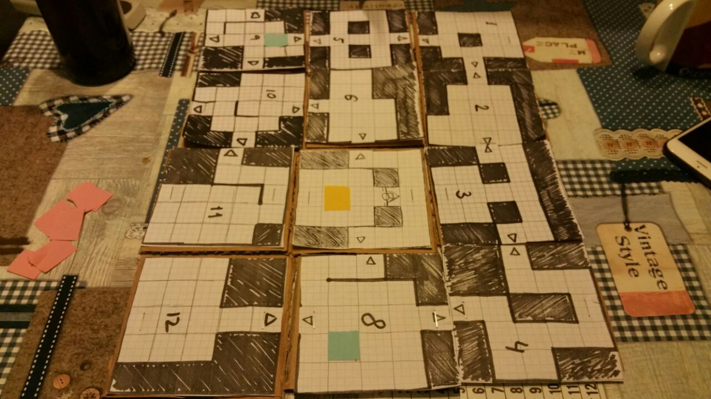Each of the tiles within a module can be either a wall (filled) or a floor. Adjacent floor tiles can also have walls between them to prevent movement from one to the other. Floor tiles at the edges of a module can contain a door connecting it to the next module.

A T-shaped divider separates the dungeon master and crawlers. This is to hide the maps of the crawlers from each other so they each have their own perspective of the dungeon. All of the boards are in the same configuration and orientation with respect the master’s point-of-view.

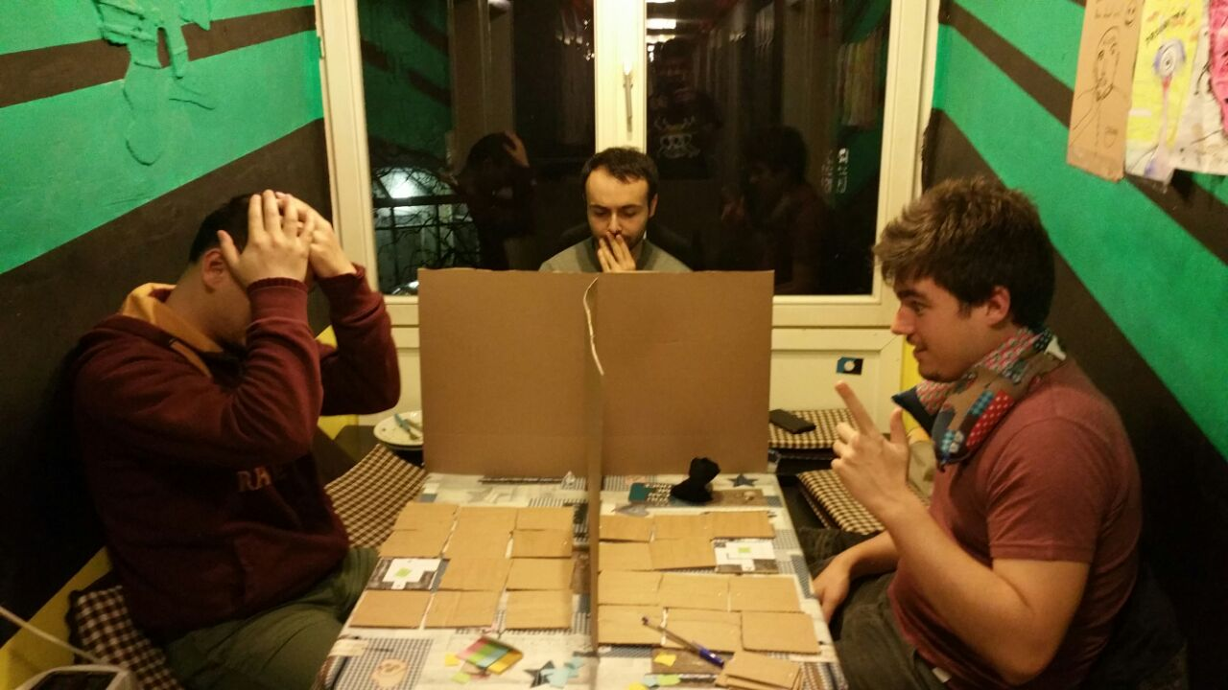The dungeon master has four ability cards, featuring a symbolic representation on the front and a number from 1-4 on the back. Further props required to play the game are two dice (D6 & D4), a black marker and post-its in four different colors.

## Entities on the map

Four distinct entities can take up a floor tile on the map. They are represented by differently colored post-its.

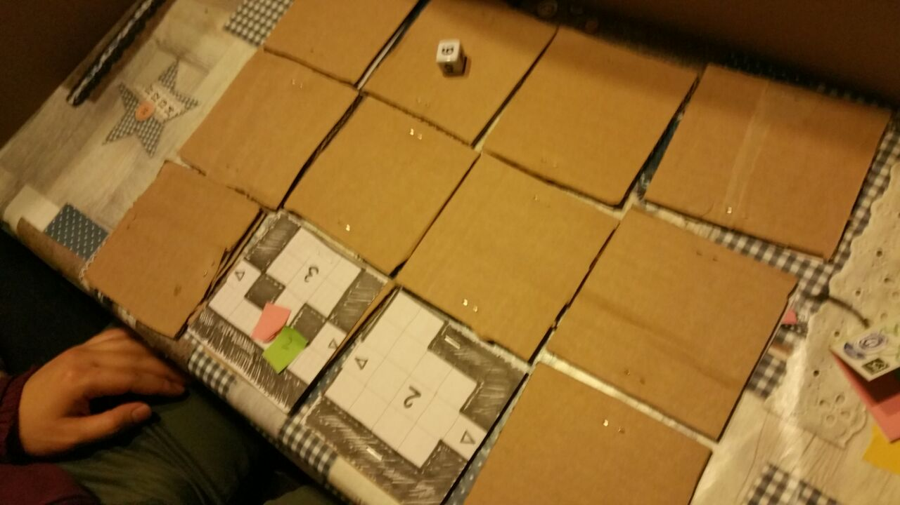Crawlers are represented by blue and the numbers 1 or 2 depending on the player controlling them. Each crawler can move up to three tiles per turn, pick up collectibles and attack one enemy in an adjacent tile.

Basic enemies are represented by red. They deal 1 point of damage per attack, have 5 HP and can move up to 2 tiles per turn.

The boss enemy is represented by yellow. It deals 2 points of damage, has 20 HP and can move up to 3 tiles per turn.

Lastly, loot, represented by green, can be picked up by crawlers by walking over the tile. It will recharge a random missing ability of the master.

## Game Setup

Before the game starts and the players can see, the game master prepares the playboards. They place players, enemies, loot and the boss on the boards. As mentioned in the basic setup, all boards are oriented to be the same when looked at from the dungeon master’s perspective.

To simulate fog of war, crawlers can only see the module they currently occupy. All other modules are flipped over to hide their contents. The dungeon master can view all modules on his map but he can only see the location of the boss enemy, crawlers and loot.

## Game loop

The turn order is:

1. Dungeon Master
2. Crawlers
3. Game Master

Before each of the other players’ turns, the game master has to make their visible modules globally consistent. If a player moves to another module, it needs to be updated so that it represents the current state of enemies and loot e.g. the other player may have picked up the loot or killed the enemy there.

The dungeon master can perform one of two actions per turn: gesture to a crawler or use an ability. This restriction is placed upon him to represent the multi-tasking constraints the master will face in the final game where he will have to guide four players at once. The dungeon master also has markers that he can place on his map to remember enemy positions as well as keep track of crawlers. This is considered a free action for him.

If the master chooses to gesture to a crawler player, the master may ignore the divider to point to a position on the crawler player’s map. This simulates the perspective of the crawlers where each of them can see the dungeon master from within the dungeon but cannot see what exactly he is pointing to unless it is close to them.

The master has four different abilities representing both direct and indirect skills: Buffs, debuffs, throwing a fireball or a healing orb. The master may not have more than one of the same ability. He will start out with none of these abilities and will only get one when a crawler picks up loot. Upon such an event, a d4 dice is rolled and an ability corresponding to the result of the dice roll is awarded to the master. This design decision was made to create some dependency on the crawlers for the dungeon master as well as to simplify loot placement through randomness.

A buff gives one targeted player double attack damage for that round. Meanwhile, a debuff will prevent one targeted enemy from attacking that round. A fireball will damage all entities within a module including crawlers. The damage will be based on a d6 dice roll. The healing orb will heal all entities in a module to full hit points. The last two abilities are module-based in order to emulate VR-induced inaccuracy.

The crawlers start by moving up to three tiles. Crawlers can only move through empty floor tiles or ones containing loot. Crawlers cannot move diagonally. When moving to another module, the crawlers have to move over the tile containing the door. The neighboring module is then flipped to reveal its contents. On leaving the door tile, the previous module is flipped face down. When moving, crawlers move their post-its to the corresponding tile.

When collecting loot, the crawler has to throw dice until one of the aforementioned abilities of the corresponding number can be awarded to the master. After this, the loot sticker is removed. If the master has all four abilities, the loot stays in place.

After moving, a crawler can attack an enemy in an adjacent tile. In this case, the player throws a D6 dice and deals that amount of damage to one specific enemy. The damage dealt is indicated on the enemies’ post-it by marker lines. If an enemy takes damage greater than or equal to its health, it dies and is therefore removed from the board.

After dungeon master and crawlers have finished their turn, the game master will play the enemies in the players’ tiles. Enemies will move towards the closest player. Enemies cannot move to other modules. After moving all visible enemies, each crawler will receive damage from adjacent enemies based on the damage of each enemy. Each enemy will only attack one crawler. As the enemies are played by the game master, she may use them as she sees fit. This emulates enemy AI in the final game.

## End Conditions

The game is lost when both crawlers are dead and won when the boss is killed, irrespective of remaining enemies.

# Results of Prototype Testing

The current design of the game ensured co-operation between the crawlers and the master. Crawler players depended on the master for advice. However, crawlers still moved and explored the map of their own free will. The crawlers co-operated with the dungeon master to locate enemies and helped each other avoid them. The master players initially focused on getting a loot item so they could be of assistance in case of emergencies.

Once the crawlers were united, things became easier for them as they could support each other directly in combat. As such, they easily went through the dungeon and defeated the boss.

### C:\Users\Jonas\AppData\Local\Microsoft\Windows\INetCache\Content.Word\WhatsApp Image 2017-11-12 at 22.52.35.jpegFun Elements

The initial phase of the game, where the dungeon master was guiding individual players and helping them sneak around the map, seemed to be fun for all players involved. There existed a strong co-operation between the crawlers and the dungeon master in this phase leading to interesting interactions and ability uses. Most immediately recognized the need to serve each other’s needs to win.

### Dull Elements

Once the crawler players met up, the role of the dungeon master seemed to be mostly over. The dungeon master just guided crawlers to the boss and seemed to have nothing to do anymore. Crawlers became more confident and rushed head long into combat. The challenge of surviving in the dungeon was significantly decreased and the master was only needed to find a quicker way to the boss enemy, and even this task was inherently lessened by the relatively small map size. Adjusting enemy threat, the master’s abilities and map complexity may reintroduce elements that made the initial phase enjoyable. Further testing will be done in the digital prototyping phase as the real-time mechanic will allow for a closer representation of the final game as opposed to the turn-based paper prototype.

## Design Revisions

What we quickly noticed during design of the prototype is that we were not specific enough in our original pitch idea regarding exactly which entities the dungeon master should be able to see and how – that it should be boss enemy, crawlers and loot, but others only through crawler callouts/ping, how we could make sure they weren’t abusing their abilities in combination with gesturing – that this would be taken care of by the natural constraint by micromanaging up to four crawlers and the inaccuracy of VR tracking, or how we should skew the balance between exploration and combat – that it is better favor exploration to promote communication with master.

Unfortunately, the nature of a paper prototype felt quite restricting when attempting to translate our core gameplay to a physical representation, be it by having to change from real-time interaction to a turn-based system, switching to a very strict “fog of war”-esque map system or needing a cumbersome game master player to act in place of a digital synchronizing server.

Nevertheless, the gameplay of the game is now more fleshed out due to our deeper discussion of individual game mechanics and player relationships.